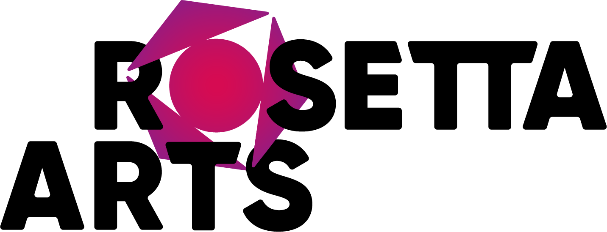

APPLICATION FORM

APPLICATION FOR: _______________________________________________________________

Your details:
Name
Address
Postcode
Telephone
Email

Qualifications:
Please give details of all qualifications, including date of completion
Qualification | Date

Education and Training / Continued Professional Development:
Please give details of all previous education / training / CPD not listed above (use a separate sheet if necessary

Employment History:
Current or most recent employer
Name of employer
Address & postcode

Job title
Length of time |  |  |  | Pay
Reason for leaving
Duties

Previous employers:
Please tell us about your previous employers, and the skills you used or learned in those posts (please use one additional sheet if necessary)

Supporting statement:
Please tell us why you applied for this job and why you think you are the best person for the job. Relate this directly to the Job Description and Person Statement. (1,500 words max)

Interview arrangements & disability:
If you have a disability, please tell us if there are any reasonable adjustments we can make to help you in your application or with our recruitment process.
Are there any dates when you will not be available for interview?
When will you be able to start working with us?

Right to work in the UK:
Do you need a work permit? | ▢ Yes ▢ No

Where did you hear about this vacancy?

▢ Arts Jobs ▢ The Guardian ▢ Arts Professional ▢ Rosetta Arts website ▢ Social media ▢ LinkedIn
▢ Other, please state:

References:
Please give the names and contact details of 2 people who we can ask to give you a reference. We may ask them before an employment offer is made. We will not ask your current employer until we get your permission. One of them must be your current / most recent employer
Referee 1
Referee 2

Declaration:
I confirm that to the best of my knowledge the information I have provided on this form is correct and I accept that providing deliberately false information could result in my dismissal.
Name
Signature
Date

PLEASE SCROLL DOWN TO COMPLETE THE SELF-DISCLOSURE STATEMENT

SELF-DISCLOSURE FORM

Roles which are exempt
Self-disclosure form for roles which are exempt from the Rehabilitation of Offenders Act 1974 in England, Scotland and Wales or the Rehabilitation of Offenders (Northern Ireland) Order 1978.
For completion by the person applying for the role.
Name
Any previous names
(please include dates each name was used from/to - dd/mm/yyyy)
Address with postcode
Telephone / mobile number
Date of birth
Gender

As the role you have applied for involves contact with children & vulnerable adults, you will also be required to undergo the relevant vetting and barring checks.

All information you provide will be treated as confidential and managed in accordance with relevant data protection legislation and guidance. You have a legal right to access any information held about you.

Have you ever been known to any Children’s Services department or police as being a risk or potential risk to children? | Yes / No (please delete or cross out as appropriate)
If yes, please provide further information:

Have you been the subject of any investigation and/or sanction by any organisation or body due to concerns about your behaviour towards children? | Yes / No (please delete or cross out as appropriate)
If yes, please provide further information and details of outcome:

Have you ever been the subject of disciplinary sanctions or been asked to leave employment or voluntary activity due to inappropriate behaviour towards children? | Yes / No (please delete or cross out as appropriate)
If yes, please provide further information:

Do you have any unspent convictions or conditional cautions?  Do you have any spent adult cautions (simple or conditional) or convictions that are not ‘protected’ as defined by either:  • the Rehabilitation of Offenders Act 1974 (Exceptions) Order 1975 as amended in England, Scotland and Wales  • or the Rehabilitation of Offenders (Northern Ireland) Order 1978 as amended in Northern Ireland? | Yes / No (please delete or cross out as appropriate)
If yes, please provide further information:

Do you have any overseas convictions? | Yes / No (please delete or cross out as appropriate)
If yes, please provide further information:

Confirmation of declaration (please tick box below)
▢ I agree that the information provided here may be processed in connection with recruitment purposes and I understand that an offer of employment may be withdrawn or disciplinary action may be taken if information is not disclosed by me and subsequently come to the organisation’s attention.
▢ In accordance with the organisation’s procedures if required I agree to provide a valid criminal record certificate and consent to the organisation clarifying any information provided on the disclosure with the agencies providing it.
▢ I agree to inform the organisation within 24 hours if I am subsequently investigated by any agency or organisation in relation to concerns about my behaviour towards children or young people.
▢ I understand that the information contained on this form, the results of the DBS check and information supplied by third parties may be supplied by the organisation to other persons or organisations in circumstances where this is considered necessary to safeguard children.
Name of candidate
Signature
Date

